GAME STORE

AIM

TO CREATE A UI DESIGN FOR GAME STORE APP

PROCEDURE

\*FIND THE COLOUR PALETTE FOR THE DESIGN

\*CREATE THE DESIGN WHERE IT SHOULD BE MINIMALISTIC AND EASY TO USE

\*PROTOTYPE THE DESIGN

\*SAVE THE COMPLETED UI

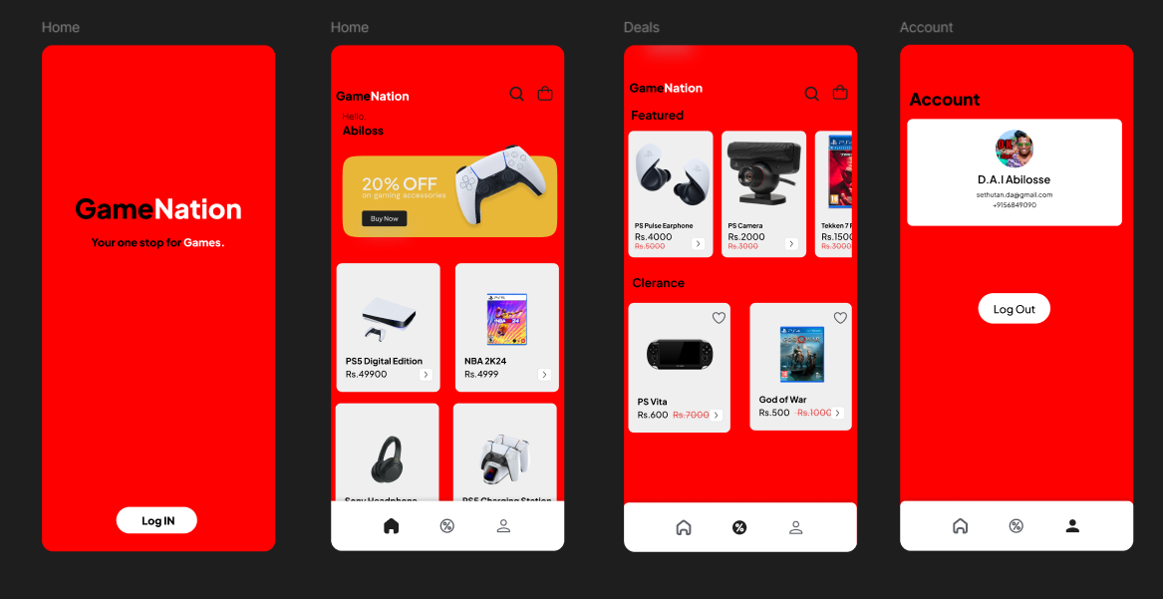

RESULT:

THE DESIGN HAS BEEN SUCCESSFULLY CREATED